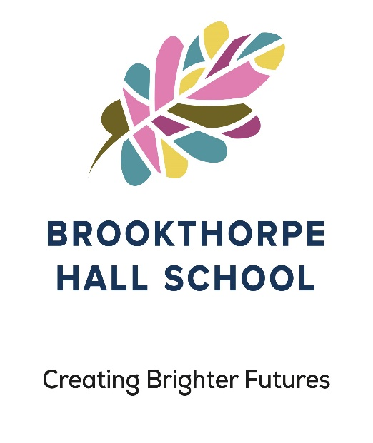

Accessibility Plan
Review Date | June 2024
Owner | Head Teacher Joy Price-Bish

Document History

Version | Comments/Amendments | Name | Date
1.0 | Version 1.0 | Joy Price-Bish | June 2022
1.1 | Version 1.1 | Joy Price-Bish | June 2023

Our Mission, Ethos and Values
This Accessibility Plan is compliant with current legislation and requirements as specified in Schedule 10, relating to Disability, of the Equality Act 2010. The Head Teacher at Brookthorpe Hall School is accountable for ensuring the implementation, review and reporting on progress of the Accessibility Plan over a prescribed period. Brookthorpe Hall School Mission Statement, School Ethos & Values, Brookthorpe Hall School aims to meet the social, emotional and educational needs of our pupils and aspire to provide opportunities that are needed to develop their full potential.
We ensure that we develop children’s spiritual, moral, social and cultural understanding. We promote the fundamental British Values of Democracy, Rule of Law, Individual Liberty and Mutual Respect and Tolerance of those with different faiths and beliefs. This weaves its way through the curriculum.

Ethos
At Brookthorpe Hall School we recognise that education for our pupils needs to provide a great deal more than the National Curriculum.
We aim to ensure that our pupils:
- Are supported to access learning opportunities in a meaningful way that takes account of their learning style and the impact of their Autistic Spectrum Condition.
- Feel confident, happy and secure in themselves, their relationships and their learning.
- Have the right to protection from all types of harm or abuse.
- Develop and maximise their ability to communicate and interact socially with others.
- Develop their ability to think flexibly, effectively and independently.
- Successfully use strategies to help them manage challenges presented by their Autistic Spectrum Disorder.
- Reach their potential academically and work towards accreditation for their learning at the highest level possible for each individual.
- Have goals and aspirations for their life beyond school and are as independent as possible in their ability to achieve them.
- Are equipped and confident to take their place in society; able to be proactive and productive members of society, accessing opportunities to continue learning or working.

To do this we ensure that:
- Pupils placed at Brookthorpe Hall School are all equally valued, respected and nurtured.
- Staff have access to on-going training, including regular child protection training.
- Pupil’s needs, including challenging behaviours, are rigorously assessed, understood and supported.
- Staff at Brookthorpe Hall School welcome collaboration with each other, parents and outside agencies and actively seek ways to promote the best outcomes for pupils and their families.
- Brookthorpe Hall School offers a school environment that meets the needs of pupils with social, emotional and mental health needs, children who have experienced early childhood trauma and also students with autism or demonstrate behaviours associated with autism in terms of structure, resources, visual and communication support.
- Brookthorpe Hall School offers an adapted curriculum that meets the needs of pupils with social, emotional and mental health needs, children who have experienced early childhood trauma. and also students with autism or demonstrate behaviours associated with autism tailored to be child centred, specialised and personalised.
- Brookthorpe Hall School bases it’s practice upon current research and recognised best practice and that staff have on-going professional development opportunities.
Vision statement: To create a safe, inclusive and nurturing environment where the curriculum is creative, sensory, meaningful and relevant to the children’s present needs and future aspirations.
We believe that every learner is ‘unique’.
Understand that everyone has the opportunity to excel and flourish in their learning.
Nurture through respect, honesty and tolerance in a safe and challenging educational environment.
Involve children, families, teachers, governors and the community to ensure that everyone is working in together successfully.
‘Quality Teach First’ to help all learners achieve their potential.
Utilise skills to promote independence and resilience that will secure a positive future for our children.
Embrace the schools belief that our children ‘Think and Learn Differently’.
Normal day-to-day activity.
The test of whether the impairment affects normal day-to-day activity is whether it affects one or more of the following:
• mobility; | • manual dexterity;
• physical co-ordination; | • ability to lift, carry or otherwise move everyday objects;
• memory or ability to concentrate, learn or understand; | • perception of risk of physical danger

The Accessibility Plan will be reported upon annually in respect of progress and outcomes, and provide a projected plan for the three-year period ahead of the next review date. This reflects new statutory requirements for the setting of Equality Objectives.
The Accessibility Plan is structured to complement and support the school’s Equality Objectives, and will similarly be published on the school website. We are committed to providing an environment that enables full curriculum access that values and includes all students, staff, parents and visitors regardless of their education, physical, sensory, social, spiritual, emotional and cultural needs. We are committed to taking positive action in the spirit of the Equality Act 2010 with regard to disability and to reinforcing our culture of inclusion, support and awareness within the school. Brookthorpe Hall School’s Accessibility Plan shows how access is to be improved for pupils with disabilities, staff and visitors to the school in a given timeframe and anticipating the need to make reasonable adjustments to accommodate their needs where practicable.
The Accessibility Plan will contain relevant and timely actions to:
Increase access to the curriculum for pupils with a disability, ensuring that pupils with a disability are as equally prepared for life as are our pupils who do not have a disability; (If a school fails to do this they are in breach of duties under the Equalities Act 2010); this covers teaching and learning and the wider curriculum of the school including leisure and cultural activities or school visits - it also covers the provision of specialist or auxiliary aids and equipment, which may assist these students in accessing the curriculum.
Curriculum – The Current Position
• Brookthorpe Hall School data system is available for all staff. | • Advanced planning for students based on ‘good’ information from the Local Authorities.
• Liaison with external services and agencies regarding individual pupils (physical, sensory, behaviour). | • High Wellbeing Plans and Risk Assessments.
• Providing a bespoke curriculum and targeted interventions from SaLT and OT. | • Developing outstanding learning and teaching across the school and in the wider community.
• Ensuring that school visits and trips are accessible for all students with Risk Assessments completed before each visit. | • Using a range of teaching methods and styles to facilitate access for all students – e.g. appropriate use of language; sensory diets; attention strategies to support all learning styles.

Physical Access - The Current Position
The school has undergone significant changes in the classrooms to make them more stimulating and engaging. The communal areas have become more sensory and offer opportunities for independent learning and self-regulation.
- Level access from car park to entrance
- Intercom access at front entrance
- All internal areas appropriately lit
- Compliant toilet facilities

Priorities for 2022/23
The forward plan will be developed in response to learners, staff and other stakeholder’s needs.
Accessibility Plan BHS AP V2 Page 6 of 6
The criteria for adapting existing or providing alternative arrangements will be assessed against individual’s specific needs. This may include but not be limited to:
• To ensure that classrooms and resources are ‘sensory and ASC friendly’. | • Provision of adapted and/or alternative work equipment and tools to meet individual’s needs.
• Provision of adapted and/or alternative workplace furniture, fixtures and fittings to meet individual’s needs.

The Accessibility Plan relates to the key aspects of physical environment, curriculum and written information. Whole school training will recognise the need to continue raising awareness for staff and governors on equality issues with reference to the Equality Act 2010. The plan should not be read in isolation and other school policies should be considered, these include (but not limited to);
• Curriculum Policy | • Health & Safety Policy
• School Behaviour Policy | • School Improvement Plan

Improve the delivery of written information to students, staff, parents and visitors with disabilities; examples might include hand-outs, visual timetables, textbooks and information about the school and school events; the information should be made available in various preferred formats within a reasonable timeframe.
• Visual timetables are produced for pupils if necessary. | • Class work is carefully adapted to ensure it is in line with pupil ability.
• The Accessibility Plan is placed on the website. | • A meeting room is available on the ground floor.

